Fairy Village
Even woodland fairies need a place to live for the summer! Let’s make some tiny homes fit for tiny fairies.

Safety Concerns / Difficulty Level
This activity requires you to go outside. Check-in with an adult before heading outside!

What materials or ingredients do we need?
- Lego person
- Optional: Small box – a show box works great
- Art Supply kit

Now that we have inspected our activities kits and gathered all the supplies, what’s next?
- Head outside! And bring your Lego person with you.
- Your Lego person is about the same size as a fairy, so use your person the gauge the size of your fairy home.
- Look around your yard for small pieces of nature that you can use in your building.
  - Twigs
  - Leaves
  - Rocks
  - Acorns
  - Blades of grass
- Next look around your house for some small household items that can add pizzazz.
- Build your Fairy Village! Pick a spot somewhere outside where your village can sit happily. You can also assemble your village in a small box so that you can move it around. You can also use other supplies in your art supply kit to make your village fabulous.

Additional Resources
Do you need some Fairy Village inspiration? Check out this website for some extra stellar houses:
https://www.familyhandyman.com/garden/15-breathtaking-diy-fairy-gardens/

Cool Activity! What else do you have for me?
Does your Fairy Village remind you of something else you might have seen before? Fairy homes look a lot like tiny Hobbit homes! Hobbits are a creature from the Lord Of The Rings Trilogy.
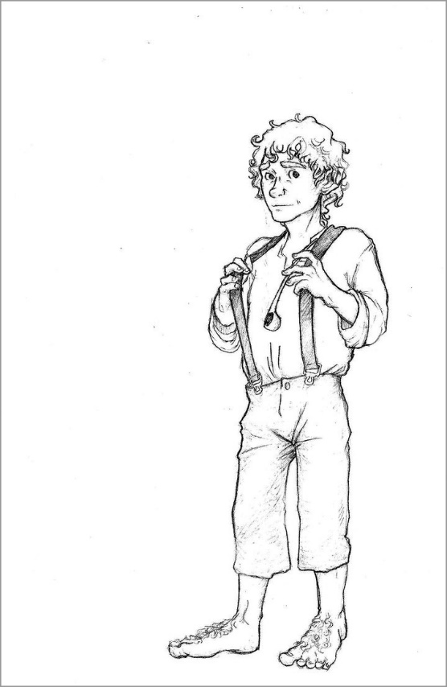
Hobbits are smaller than humans, have pointy ears (like elves), and have large hairy feet.
Let’s explore a little more about the world of Hobbits…like their alphabet!
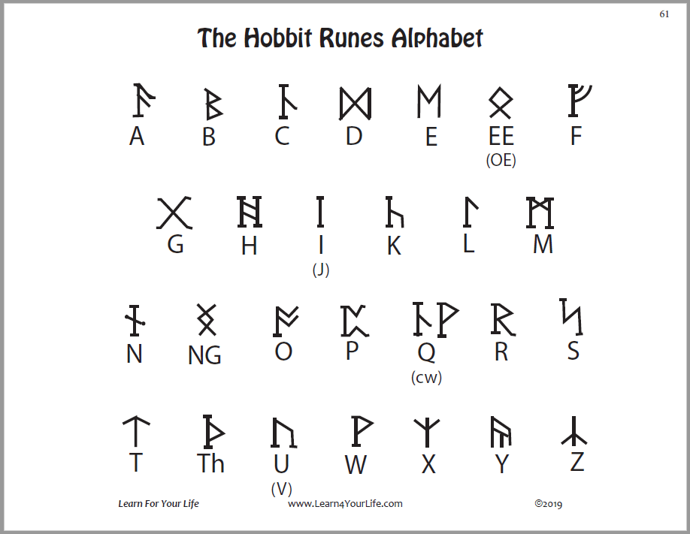
Can you write your name in Runes? What else can you write in runes?

